Assignment 2 Part 2

Usability Engineering

Rotten Tomatoes (www.rottentomatoes.com/)

|  |  |
| --- | --- |
| Test Date | 19th April to 27th April 2019 |
| Report Date |  |
| Student name and number | Todd Johnston S3660590  David Manolitsas S3779380  Jessica Cui S3763636 |

**Table of Contents**

**Executive Summary 3**

**Introduction 4**

**Overview of site 4**

**Scope 4**

**Test Objectives 5**

**Method 5**

**User Profile 6**

**Participants 6**

**Tasks 7**

*Task Procedure 7*

*Task Outline 7*

**Test Environment 8**

*Test Facility 8*

*Computing Environment 8*

*Display Environment 9*

**Usability Metrics 9**

**Results 11**

*Quantitative Data Analysis 11*

Mean Time Completion 11

Unassisted and Assisted Completion Rate Comparison 11

Errors 12

Data Scoring 13

System Usability Scale 13

Post-Test Likert Scale Questions 14

*Qualitative Data Analysis 16*

Nielson’s 10 Heuristics 16

Affinity Diagram 17

*Findings and Observations 18*

**Recommendations 19**

**Conclusion 20**

**References 20**

**Appendix 21**

*Appendix A – Data Collection Forms 21*

A.1 Screening and Pre-test Questionnaire 21

A.2 Consent Release Form 31

A.3 Task Scenarios 36

A.4 Post-Test Questionnaire 37

A.5 Data Observation Notes 47

A.6 Facilitators Script 49

A.7 Raw Spreadsheet of data 49

*Appendix B – Screen Shots 50*

Figure B.1 50

Figure B.2 50

Figure B.3 50

Figure B.4 51

Figure B.5 51

Figure B.6 52

*Appendix C – Affinity Diagram 53*

# Executive Summary

Usability testing was conducted on a film and television review website called Rotten Tomatoes (*RT*), rottentomatoes.com. *RT* is a collaborative discussion website featuring reviews and ratings from critics as well as enthusiasts, and it also provides a movie session locating service. The purpose of this test was to test the usability of *RT’s* user interface and information architecture (IA). 5 participants were recruited directly on RMIT campus and testing occurred between the 19th and 27th April 2019. Of the five participants recruited, only one had previous experience with *RT*. Every session consisting of six tasks took no longer than 45 minutes, and there was a single facilitator and two observers for every session.

The usability test found that *RT* scored below average on the System Usability Scale (SUS), with an average score of 51 and a range between 30 and 67.5. Participants became frustrated and confused with many aspects of the interface and IA during the tasks. Although most tasks were able to be completed by participants without any assistance, there were a couple tasks where completion could not occur because the navigation structure of *RT* hindered participants.

Some issues with the usability *RT* were:

* A poorly constructed IA hierarchy that prevented website navigation
* Lack of error prevention when submitting an application to become a critic
* A lack of multiple pathways to a single section which hindered flexibility options
* Unaesthetic website interface design

An extremely major and persistent issue discovered was *RT’s* own rating system of the “Tomatometer” (*TM*). Participants did not understand this unique ranking and it caused them to expend additional cognitive effort and detracted from the user experience.

The report has found that for participants with any level of computing experience, *RT* is at best, just functional website. Based on test results and feedback from participants, *RT* is not an engaging website with its many sources of barriers and ineffective website layout.

Some recommendations discussed:

* Improved navigational features in terms of menu structure and a pathing navigation system (See *Appendix B.3* for example)
* More obvious call to action buttons that inform the user accurately and concisely as to what that link will do
* Error prompt messages for important transactions
* Multiple pathways to pages to improve website flexibility
* A clearer outline of the *TM* and its meaning

The findings of this report are limited as the sample size for this study is not representative of the entire RT user base. Future studies may want to test a larger pool with a broader range of participant demographics. Another limitation was the test room that did not simulate an ideal laboratory environment. It would be recommended to use a formal usability lab with specific equipment in further tests.

# Introduction

The usability of a system is an important factor in its ability to both attract new users and retain existing ones, pertaining to its growth and the success of the associated business. Usability is defined by the extent to which users can achieve their objectives efficiently, effectively and satisfactorily (Interaction Design Foundation, N/A). Systems that do not ensure a high level of usability in the modern age can quickly become outcasts because users will opt for competitor systems with more engaging interfaces. Usability of a system can be analysed using a number of statistical measures and heuristics to determine its functionality in the eyes of the user.

The following report is an analysis on the usability of *RT* and its subsequent features with the aid of both quantitative and qualitative research methods including Nielsen's 10 Heuristics of Usability (Nielson, 1994). *RT’s* most critical aspects will be subjected to a series of tests wherein our participants are given tasks that attempt to divulge any faults and critical problems within the site. The raw results of these usability tests will be presented and then used to form the basis for our analysis from which we will attempt to conclude the overall usability of the website, in both the eyes of the average user and the researchers. Lastly, we will suggest any changes we believe to be desirable in increasing the usability of the *RT* website and conclude our findings and suggestions. The appendix may be used as a reference in these findings and is located at the bottom of the report.

# Overview of site

* The website tested in this report is Rotten Tomatoes**:** ([https://www.rottentomatoes.com](https://www.rottentomatoes.com/)).
  + It is a collaborative film and television review website.
  + It allows both film and television critics to review media as well as regular users
* The date that participants were tested ranged between 19/4/2019 and 27/4/2019.

# Scope

* Some essential IA structure was evaluated as a part of the test:
  + Menu bar which included the *Movies, News* and *Tickets & Showtimes* top down navigational hierarchies
  + This was to determine if how effectively RT categorised their content and how usable that design was
* Search bar and filtering system
  + To determine if users were able to search, browse and navigate media content on a personalised level
* The website specific ranking of *TM*
  + To determine how meaningful and suitable that ranking system was to users
* Quick links located at the top and bottom of the interface
  + To determine how effectively and efficient users could access supplementary content such as critic-related information and the *TM*

# Test Objectives

Objective 1: Determine overall user satisfaction of the user interface of RT using:

* Satisfaction of users according to System Usability Scale (SUS)

Objective 2: Test the ease of use, efficiency and effectiveness of *RTs’* IA:

* Efficiency of site is measured by completion times.
* Effectiveness of site is measured by completion rate and assisted completion rate.

Objective 3: Determine the learnability of *RT* ranking system.

Objective 4: Testing the usability of process of becoming a critic.

# Method

Five participants were recruited by directly approaching our peers at RMIT University and asking them to fill in the screener pre-test questions to filter through to find suitable participants. The pre-test questions examined the participants’ web experience as well as overall habits pertaining to film and television. Each participant was invited to a RMIT classroom between the 19th and 27th of April where they were welcomed with the facilitator script and informed of their rights as a participant and reminded of the use of a screen recording. Participants were provided food and drink during their session as compensation.

Participants sat down to sign the consent form and then answered the pre-test questions. The total time for the entire usability test was 45 minutes, with approximately 10 minutes for post test questions, 20 minutes allocated for six usability tasks and another 10 minutes for debrief. After each session, the research team of three rotated responsibilities of facilitator and observer, with a single researcher facilitating and two observing at all times.

A laptop was provided to the users to complete the tasks on, formatted with screen recording software and an ad blocker. As the three facilitators rotated, so did the laptop device (see Computing Environment for specifications). After the participant finished the tasks, a debrief occurred before the post-test questionnaire where any questions the participant had were finally answered. The post-test questionnaire was a combination of various types of questions, a full list of documents is listed in *Appendix A*.

Some open and closed ended questions measuring:

* Likes and dislikes of *RT*
* Emotions of the participant
* General opinion of the user interface
* Likelihood that user would reuse the website

A 5-point Likert scale measuring:

* Usefulness of certain features
* Ease of use of certain features

A SUS measuring:

* Participant satisfaction
* Participant emotions
* Complexity of the website

Measures that were recorded during the test were the number of assists per tasks and errors.

* Number of assists per tasks:
  + Only applicable for tasks for Tasks 3 and 6
  + A maximum assist of 1 was allowed
  + Facilitator is allowed to prompt participant of the general area on the interface they should look only once throughout the entire task
* Number of errors:
  + Any time a user clicked on a wrong link
  + Any time a user searched the wrong term
  + Any time a user reverted back to the home page to start over
  + Count started at 0 for each task and incremented ever error a participant made

# User Profile

The user profile of the participants that could be recruited in this experiment are university students aged between 18 and 26 years of age with interest in television and film who may or may not have had experience with the RT website. This sample size is only a subset of the entire user population of RT and it is not a fully representative sample. The user population for RT would be any person who has web access and is interested in supplementary information about movies and television.

# Participants

A. The total number of participants tested:

* Five

B. Segmentation of user groups tested, if more than one:

* N/A, only university students aged 19 - 23 were tested

C. Key characteristics and capabilities of user group:

* University students with computing experience
* Had web access regularly in their personal lives
* Enjoyed searching the web for supplementary information about the media they watched/are about to watch
* Were interested in film and television, though not necessarily interested in *RT*

D. How participants were selected; whether they had the essential characteristics.

* Direct approach

E. Differences between the participant sample and the user population.

* Ages ranged from 19 - 23 years of age
* 3 females and 2 males
* All 5 participants were students
* Varying levels of experience with computers
* Participant 5 had previous experience with *RT* unlike the other 4 participants

|  |  |  |  |  |  |
| --- | --- | --- | --- | --- | --- |
|  | **Age** | **Gender** | **Occupation** | **Computing Experience** | **Previous Experience** |
| **Participant 1** | 23 | Male | Student | Medium | No |
| **Participant 2** | 23 | Female | Student | Medium | No |
| **Participant 3** | 19 | Female | Student | Low - Medium | No |
| **Participant 4** | 22 | Female | Student | High | No |
| **Participant 5** | 21 | Male | Student | High | Yes |

*Figure 1 Participant Information.*

# Tasks

## Task Procedure

Participants were informed that although they could ask the facilitator any questions they wished, they would not always get an answer if it would bias the participant. Each task had a maximum time limit where the task was terminated if a participant could not complete it. Tasks 3 and 6 allowed an assist from the facilitator if the facilitator believed it necessary.

## Task Outline

**Task 1 - Tomatometer rating**

The first task asked the participant to find out the meaning of the *TM* and its icons. It was also required for the participant to find information on how the *TM* scores were calculated.

Why this task was selected:

* Understanding the ranking system leads to understanding of *RTs*’ website organisation and structure
* It provides meaning to users and is an indicator of a movie or television show’s standing

**Task 2 - Genre Search**

Task 2 required participants to filter movies that were currently in cinemas based on the specific genre horror.

Why this task was selected:

* It is important to be able test how *RT* allowed users to filter film and television media by different categories
* This task chose the category ‘horror’ to mimic a real-world desire to filter on a basic genre

**Task 3 - 110 Best Sci-Fi movies**

In this scenario, the participant was required to find an article listing the ranking of the *“110 Best Science Fiction Movies”*. Additionally, the task asked the participant to find what the number one ranked movie was in this list.

Why this task was selected:

* This was the most difficult task as it required cognitive effort from the user to be able to navigate the IA of *RT* with the information scent slightly blocked
* This task encouraged users to browse areas of *RT* that they may not typically explore

**Task 4 - Filter a movie based on tomatometer rating**

The participant was instructed to use the RT website to filter movies based on the *TM* rating. It was required that the participant filters movies specifically between 0% to 40%.

Why this task was selected:

* As the *TM* is such an integral part to the *RT* interface, it is important to be able to filter films and television shows based on this ranking system

**Task 5 - Become a Critic**

This scenario put the participant in the shoes of a critic and asked the participant to find out all the information required to apply to be a critic on *RT* and have their reviews posted on the site. It required participants to fill out the application but not submit.

Why this task was selected:

* *RT* is a collaborative website and it invites inputs from its users
* Any audience member can provide input as long as they have an account, but the process to provide input as a critic is more formal
* It was important to test the process of finding application information and test the application process’ usability

**Task 6 - Find a movie and session time**

This scenario required the participant to pretend they were planning a holiday to Los Angeles. The participant was given a postcode (90210) and asked for them to find a movie session time at a local AMC theatre between the hours of 12:00pm and 5:00pm for any movie. Furthermore, the task also needed the participant to select seats in the front row and checkout.

Why this task was selected:

* Most complex task in terms of the number of clicks required but still familiar to many internet users
* This tested how effectively a user could select a movie session and purchase a ticket to that movie theatre

See *Appendix A.3* for a more detailed description of task scenarios.

# 

# Test Environment

## Test Facility

Test Facility: RMIT classroom 14.11.38

## Computing Environment

*Computer Configuration:*

* MacBook Pro (13-inch, Early 2015), MacOS Mojave
* MacBook Air (13-inch, Early 2013), MacOS High Sierra
* Dell Inspiron 15 (early 2016), Windows 10

*Required libraries:* N/A

*Computer Settings:*Default settings

*Browser Name and Version:*

* Chrome Version 74.0.3729.108
* Safari Version 11.1

*Plug-ins:*  AdBlock

*Additional features used:*

* *Screen recording software:*
  + Silverback
  + Free Cam 8
* Simple note taking on paper (real-time observations) or on another laptop

## Display Environment

*Screen size:* 13”

*Screen Resolution:* 2560x1440

*Screen Frequency:* 60Hz

*Screen Colour:*RGB

*Internet connection:* RMIT-University Wi-Fi

*Mouse:* Laptop trackpad

### 

# Usability Metrics

We measured the effectiveness of the RT system using the following metrics:

* Completion rate - Binary value representing whether or not the user completed the task.
* Assist rate - The number of times a user had to be directed towards the solution for a task.

**Completion and Assist Rate Per Task**

|  |  |  |  |  |  |  |  |  |  |  |  |  |
| --- | --- | --- | --- | --- | --- | --- | --- | --- | --- | --- | --- | --- |
|  | Task 1 | Assists | Task 2 | Assists | Task 3 | Assists | Task 4 | Assists | Task 5 | Assists | Task 6 | Assists |
| User 1 | 1 | 0 | 1 | 0 | 1 | 1 | 1 | 0 | 1 | 0 | 1 | 0 |
| User 2 | 1 | 0 | 1 | 0 | 0 | 1 | 0 | 1 | 1 | 0 | 1 | 0 |
| User 3 | 0 | 0 | 1 | 0 | 1 | 1 | 1 | 0 | 1 | 0 | 1 | 0 |
| User 4 | 1 | 0 | 1 | 0 | 1 | 0 | 1 | 0 | 1 | 0 | 1 | 0 |
| User 5 | 1 | 0 | 1 | 0 | 1 | 1 | 1 | 0 | 1 | 0 | 1 | 1 |
| Total Completion Rate | 80.00% | 0.00% | 100.00% | 0.00% | 80.00% | 80.00% | 80.00% | 20.00% | 100.00% | 0.00% | 100.00% | 20.00% |

*Figure 2 Completion and Assist Rate.*

Next we can break down total completion rate into unassisted and assisted completion rate:

* Assisted completion rate - The rate at which tasks were completed when an assist was given to the test user.

**Unassisted and Assisted Completion Rates**

|  |  |  |  |  |  |  |
| --- | --- | --- | --- | --- | --- | --- |
|  | Task 1 | Task 2 | Task 3 | Task 4 | Task 5 | Task 6 |
| Unassisted Completion Rate | 80.00% | 100.00% | 20.00% | 80.00% | 100.00% | 80.00% |
| Assisted Completion Rate | 0.00% | 0.00% | 60.00% | 0.00% | 0.00% | 20.00% |

*Figure 3 Unassisted and Assisted Completion Rates.*

* Error Rate - The number of errors recorded by our observers that were deemed detrimental to the completion of the task (see limitations for definition of error).

**Error Rating Per Task**

|  |  |  |  |  |  |  |
| --- | --- | --- | --- | --- | --- | --- |
| Errors | Task 1 | Task 2 | Task 3 | Task 4 | Task 5 | Task 6 |
| User 1 | 0 | 3 | 2 | 2 | 2 | 0 |
| User 2 | 4 | 4 | 7 | 3 | 0 | 2 |
| User 3 | 6 | 1 | 5 | 0 | 1 | 2 |
| User 4 | 1 | 1 | 0 | 4 | 0 | 0 |
| User 5 | 3 | 0 | 2 | 0 | 1 | 1 |
| Mean | 2.8 | 1.8 | 3.2 | 1.8 | 0.8 | 1 |

*Figure 4 Error Rating Per Task.*

We measured the efficiency of the *RT* by comparing the completion time of each task with our predetermined expected times for each task.

**Raw Times Recorded**

|  |  |  |  |  |  |  |
| --- | --- | --- | --- | --- | --- | --- |
|  | Task 1 | Task 2 | Task 3 | Task 4 | Task 5 | Task 6 |
| User 1 | 00:21 | 01:58 | 01:36 | 01:57 | 01:32 | 02:58 |
| User 2 | 03:45 | 03:05 | 04:08 | 04:10 | 01:40 | 03:30 |
| User 3 | 04:07 | 00:44 | 04:07 | 01:35 | 05:06 | 03:47 |
| User 4 | 01:08 | 02:11 | 01:25 | 02:58 | 00:56 | 02:58 |
| User 5 | 01:45 | 01:15 | 01:46 | 00:47 | 01:23 | 02:03 |
| Mean time | 02:13 | 01:50 | 02:36 | 02:17 | 02:07 | 03:03 |
| Expected | 02:00 | 01:30 | 03:00 | 03:00 | 01:00 | 05:00 |
| SD | 0.069 | 0.038 | 0.058 | 0.055 | 0.070 | 0.028 |

*Figure 5 Raw Times.*

**Expected Time vs. Recorded Times of Completion**

|  |  |  |  |  |  |
| --- | --- | --- | --- | --- | --- |
| Task 1 | Task 2 | Task 3 | Task 4 | Task 5 | Task 6 |
| 6.88% | 1.94% | 5.83% | -4.38% | -2.22% | -8.47% |
| 7.29% | 6.60% | 4.72% | 4.86% | 2.78% | -6.25% |
| -8.82% | 3.19% | -4.65% | 5.90% | -17.08% | 5.07% |
| 3.61% | -2.85% | 6.60% | 0.14% | 0.28% | 8.47% |
| 1.04% | 1.04% | 5.14% | 9.24% | -1.60% | 12.29% |

*Figure 6 Expected Time vs. Recorded Times.*

Write a couple of dot points talking about these 2 tables?

* The mean time recorded for an individual task can help to extrapolate a general idea of its difficulty when compared to its counterparts, as those with longer completion times likely entailed a solution that was more difficult to reach.
* By comparing these raw times with each other we can hope to reveal trends in which tasks troubled particular users, causing us to be wary of outliers with both experienced and inexperienced users.
* When analysing the expected times vs recorded times of completion, we hope to gain an idea of the overall efficiency as well as effectiveness of the site by showing how long users took to complete tasks vs what we believed was a reasonable time for the average user to find a solution.

# Results

## Quantitative Data Analysis

### Mean Time Completion

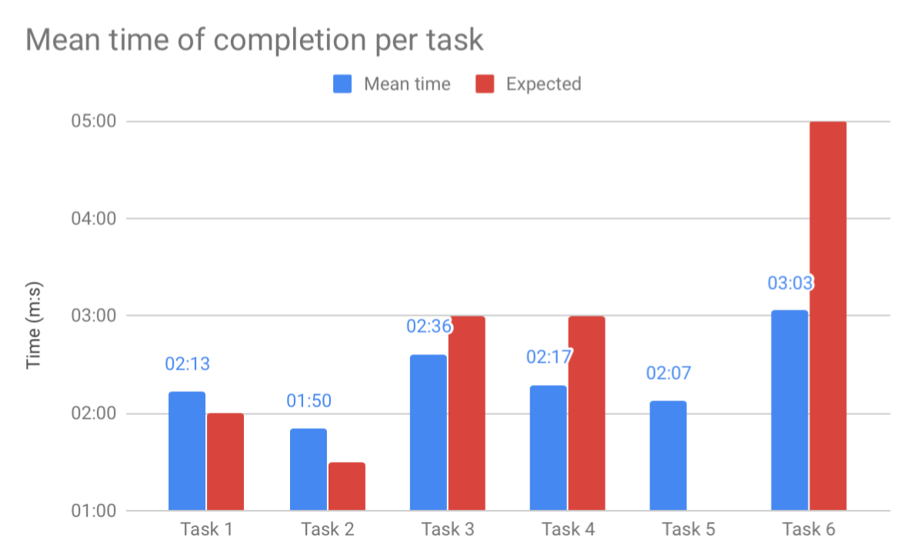

*Figure 7 Mean Time of Completion Per Task*

In our initial task creations, we set an expected time for each of our individual tasks. These times ranged from 30 seconds through to a full 5 minutes. The average time taken across all tasks from each user shows that our expected times were, for the most part, in the correct range (See *Figure 7*). The average completion time of Task 1 of two minutes and thirteen seconds, is a concerning figure as the task can be completed almost instantly from the home page of *RT*, requiring a single click on a link in the top right corner (See *Appendix B.2*). This suggests that the site is not clear enough in distinguishing the link to the *TM* information page. One user even took as long as 4 minutes to complete the task, making as many as 5 errors along the way. This time is unrealistic, and this user ended up giving up and not completing the task, an indicator of *RT’s* complexity and lack of clear signage.

### Unassisted and Assisted Completion Rate Comparison

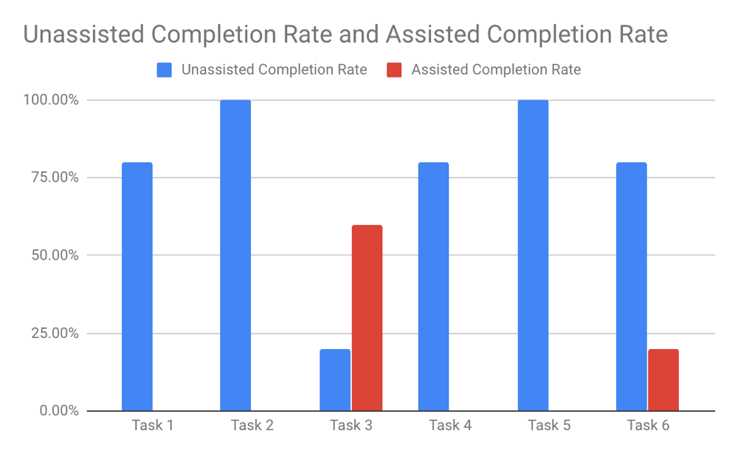

*Figure 8 Completion Rates.*

The completion and assisted completion rates of the multiple tasks are indicative of the overall difficulty of the *RT* system as well as the tasks themselves. Of the six tasks that were tested, only two resulted in a 100% completion rate (*Figure 8*), and the other four tasks varied in both completion and assisted completion rate. The two tasks that had a 100% completion rate also had the fastest mean completion time and they were the tasks testing *RT’s* interface functionality. This advocates that the *RT* interface is a strong point of the site and enables a level of functionality not seen in other areas.

Task 3 had the greatest variance in both metrics of completion rate and assist rate, with an assisted completion rate of 60%, 40% higher than the next closest task. This suggests that participants had particular difficulty with the core concept of this task, finding a specific article, with multiple errors being commonplace during testing.

### Errors

Throughout the process of the testing, our observers noted down the number of errors that were made by each individual user per task. This was done to measure how easily a participant could use the system as well as gauge the ability of *RT*’s error prevention. According to our criteria, a task was required to be performed with no errors for it to be completed/performed at 100%, this occurred 9 out of a possible 30 times with each task having at least one instance of a user finishing with 0 errors. Therefore, *RT* has the potential to be a highly effective system but many of majority of our participants encountered too many errors.

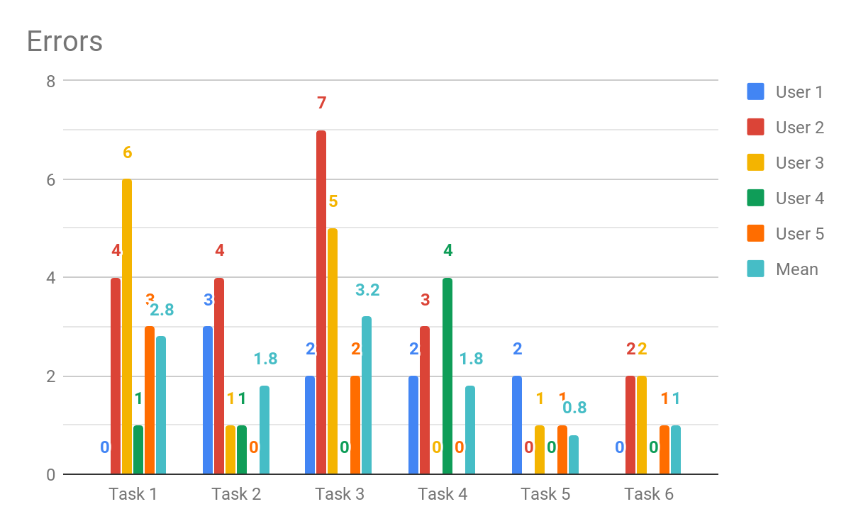

*Figure 9 Errors.*

Two of the tasks, Task 1 and Task 3, recorded an average number of 2.8 and 3.2 errors respectively (*Figure 11*). In Task 1 it is clear that users are often making a large number of errors trying to find the meaning of the *TM*, one user even made as many as 6 errors trying to complete the task. This is a severe number of errors for a task which can have a relatively short completion time and a feature that is centric to the *RT* model.

In designing Task 3 we hoped to test the participant’s usage on the *RT* search bar by asking participants to locate an article that was only available in the *News* section of the menu. As aforementioned, this task recorded an average of 3.2 errors with nearly every user opting to try and find the article with the search bar feature. The search bar does not return news articles and as a result, participants were left with no real idea of where to go next. Even for participant 5 who had previous experience with *RT*, finding any specific article within *RT* proved a challenge. Thus, *RT* would do well in enabling their search bar to feature articles instead of solely list movies and TV shows.

### Data Scoring

**Effectiveness Rate is calculated as 100 - (Errors per Task * 10) + (Percentage Difference vs Expected Time * 5).**

|  |  |  |  |  |  |  |
| --- | --- | --- | --- | --- | --- | --- |
| Effectiveness Rate | Task 1 | Task 2 | Task 3 | Task 4 | Task 5 | Task 6 |
| Participant 1 | 100.0 | 79.7 | 100.0 | 58.1 | 68.9 | 57.6 |
| Participant 2 | 96.5 | 93.0 | 53.6 | 94.3 | 100.0 | 48.8 |
| Participant 3 | 0.0 | 100.0 | 26.7 | 100.0 | 4.6 | 100.0 |
| Participant 4 | 100.0 | 75.8 | 100.0 | 60.7 | 100.0 | 100.0 |
| Participant 5 | 75.2 | 100.0 | 100.0 | 100.0 | 82.0 | 100.0 |
| Mean | 74.3 | 89.7 | 76.1 | 82.6 | 71.1 | 81.3 |

*Figure 10 Effectiveness Rate.*

As seen in *Figure 12*, the average effectiveness rate of *RT* ranges from 71.1 to 89.7, indicating that the system’s functionality is adequate because users can achieve their goals. The interface is just not an ideal one at that as there are still some participants who struggled greatly with particular tasks, especially Participant 3. This suggests that because of poor IA structure and system design, users can commit too many errors that can cause them to deviate from their desired goal, resulting in frustration with the system and reduced usability.

### System Usability Scale

**SUS Questions:**

Each participant was asked to rate their answer on a scale of 1 to 5, with 1 being they disagree with the statement and 5 being they agree with the statement.

1. I think that I would like to use this system frequently
2. I found the system unnecessarily complex
3. I thought the system was easy to use
4. I think that I would need the support of a technical person to be able to use this system
5. I found various functions in this system were well integrated
6. I thought there was too much inconsistency in this system
7. I would imagine that most people would learn to use this system very quickly
8. I found the system very cumbersome to use
9. I felt very confident using the system
10. I needed to learn a lot of things before I could get going with this system

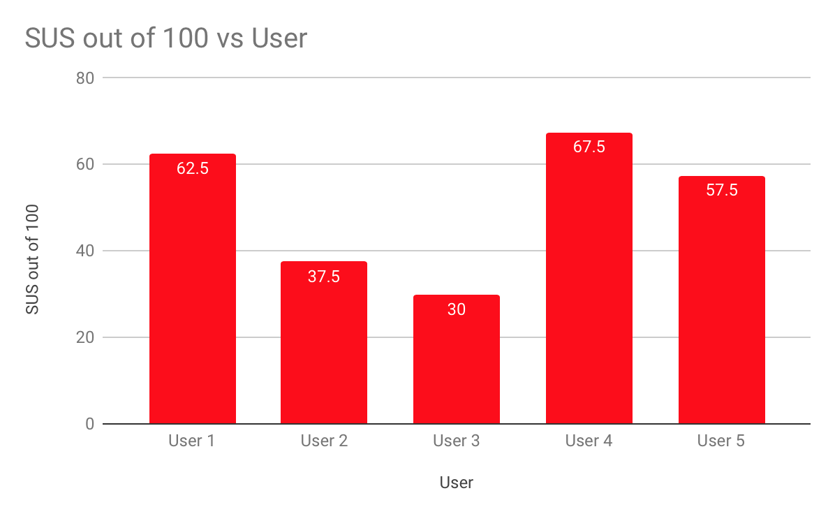

*Figure 11 SUS Scores.*

The results from our SUS questionnaire (*Figure 9*) yielded differing perspectives from each participant. Whilst there were varying answers from all our participants, there is a clear general trend of sub-par scores recorded from the participants. The average score of an acceptable system is 68 (usability.gov, 2019), in stark contrast the *RT* system recorded below average for all six tasks and a combined overall average score of 51, an indicator that participants struggled with the overall usability of the website and deemed it less than satisfactory. Furthermore, the lowest score recorded was that of just 30, implying that some user who are not as adept with web use may seriously struggle with the usability of the *RT* website.

### Post-Test Likert Scale Questions

Each participant was asked to rate their answer on a scale of 1 to 5, with being they disagree with the statement and 5 being they agree with the statement.

**Questions:**

Q7. How useful do you think the navigation menu was?

Q8. How useful were the search filter options?

Q9. How useful was the feature to locate a move and purchase tickets?

Q11. How easy was the process to become a critic?

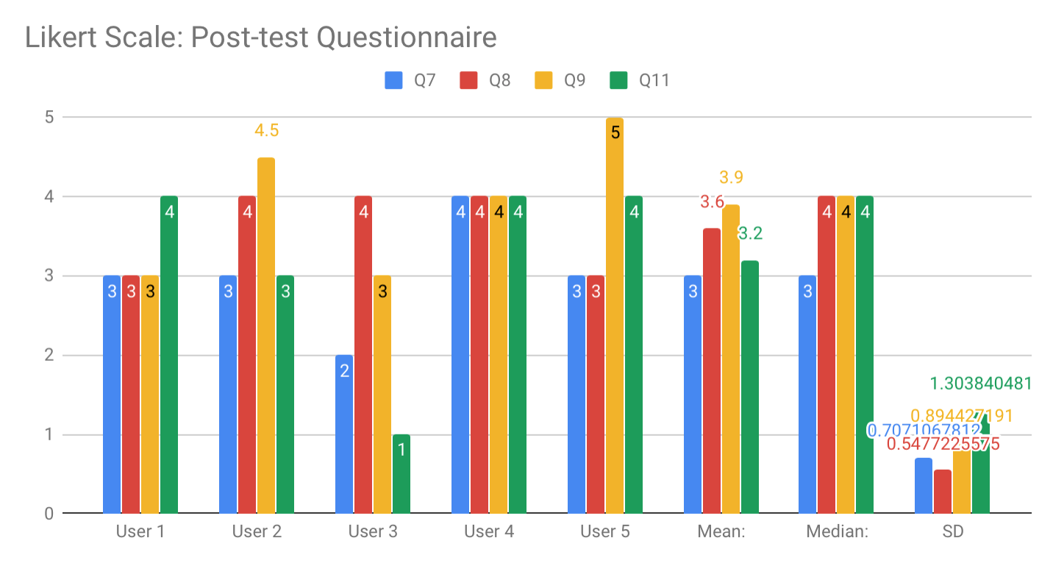

*Figure 12 Likert Scale.*

Whilst our SUS score provided a great general overview of the speculated system the use of our post-test Likert scale allowed us to get more specific in regard to certain aspects of *RT*’s usability. The question of “How useful do you think the navigation menu was?” drew a mean score of 3, suggesting that participants were fairly neutral on the usefulness of the site’s navigation bar, a feature that is centric to entertaining good site architecture and perhaps should command a higher score.

The next question of our Likert set asked “How useful were the search filter options?”, a specialised feature of the site that should avoid a negative response from the users. The mean result of this question was a 3.6, a better result but for a more obscure feature. None the less users were apparently somewhat pleased with the presence of the search filter options.

Third in our set of Likert scale questions was “How useful was the feature to locate a movie and purchase tickets?”, a probe into the user satisfaction associated with *RT*’s inbuilt feature for booking tickets and viewing showtimes. Out of all our Likert scores this feature polled the highest mean score of 3.9. Users clearly found use for the booking system as it appears to be one of the most engaging aspects of the *RT* site.

Lastly, we asked our participants “How easy was the process to become a critic?” as a way to test a part of the website that the average user would be unlikely to interact with. Upon first glance the mean score of 3.2 does not make it seem as though this feature is very helpful, however with a single user giving a score of just 1 deeming the usefulness of the critic application near incompetent the results may be skewed. When looking at the median result of 4 which was given by 3 other uses it is clear that this feature has potential to increase its usability to a higher standard than that of the overall *RT* site.

## Qualitative Data Analysis

The following qualitative analysis based on Nielson’s 10 Heuristics (Nielson, 1994) and the severity rating was initially completed by each individual researcher to identify themes separately, before a group analysis compiled and identified commonly recurring themes and issues. Only the relevant heuristics to *RT* were used in the qualitative analysis.

### Nielson’s 10 Heuristics

**Match Between System and The Real World:** The interface of RT should match real world contexts for evaluating movies and television

Severity Rating: Medium to High

RT uses their individual site-specific rating to indicate a movie or television show’s standing amongst their peers with icons and percentages

|  |  |  |  |
| --- | --- | --- | --- |
| **Tomatometer key icons** | “Certified Fresh” |  |  |

*Figure 13 (Rotten Tomatoes Tomatometer icons, 2019)*

* The icons provide no significant meaning to participants
* All participants with no prior knowledge of RT found it difficult to determine the meaning of all these icons as it was an unfamiliar concept
* Participants only understood the percentage rankings instead as that is something they were familiar with
* The lack of understanding of what the Tomatometer was caused a lot of confusion, frustration and required strenuous mental effort.

**Recognition Rather Than Recall:** Reduce cognitive effort required by users by providing visibility of objects and prompts where needed

Severity Rating: Low

* RT does try to use an icon system to convey meaning to users so it assists in recognition, but only as long as users have overcome the initial cognitive effort of memorising the meaning
* Ratings are supplemented by percentages even if users forget the meaning of the Tomatometer
* The search bar does list some auto fill options for users when they begin typing, but it is not optimised

**Help users, recognise, diagnose and recover from errors:** RT should provide error messages and solutions to any errors that occur

Severity: Medium to High

* There is no button for the user to go back on the website if they make an error
* The user can only return to the previous page by using the web browsers’ “back button”
* While this may only be a slight inconvenience at times, during more pivotal moments such as booking a movie session time the impact is far more severe.
* During the critic application there is no way for a critic so retract their submission

**Error Prevention:** The prevention of errors from occurring in the first place

Severity: Low to Medium

* RT uses little to no error prompts
  + Checkout doesn’t have any error prompts asking the user to verify
  + Selecting a time for a movie session automatically redirects the user to the next page

**Aesthetic and Minimalist Design:** Interface should be organised, and any redundancies should be removed

Severity: Medium

* There is too much content on the screen at one time, which can be overwhelming
* When trying to filter movies there are a lot of different options such as “Top Box Office” and “Coming Soon to Theatres” which can make it difficult to find exactly what you’re looking for
  + There is no option to filter movies as a whole because they segregated into too many subcategories (See *Appendix B.1* for a visual example)
* The menu bar layout did not categorise topics effectively, which caused a lot of confusion during navigation
  + Participants specifically found it irrelevant to have movie ranking lists under the *News* tab which made it difficult to complete Task 3

### Affinity Diagram

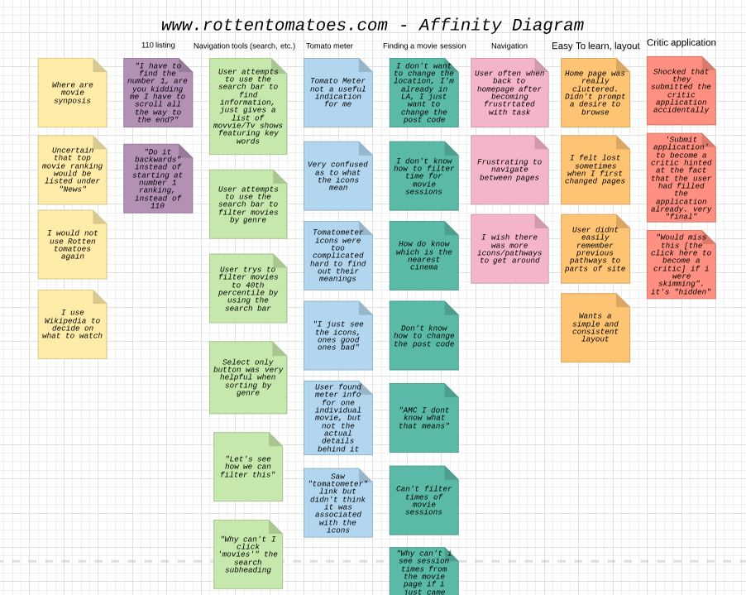

*Figure 14 Affinity Diagram.*

Using an affinity diagram, the main issues identified pertained to the *TM,* the navigation and the navigational tools and finding a movie session

* Participants did not understand the *TM* rating system
* They found that the *TM* was not a relevant rating system for them
* Participants found it difficult to navigate through the tasks using the menu bar and search tool
* The frustrating aspect of navigation caused participants to return to the home page to restart tasks
* The initial process for filtering locations for movie theatres and session times was inefficient as participants found it slightly inconvenient to filter location
* The remaining process of selecting and paying for tickets did not raise any issues

See *Appendix C* for the creation process of affinity diagram.

## Findings and Observations

**Task 1 Findings**

There were varying results between different participants in their ability to locate information about the *TM* ranking system. The main obstacle was a lack of understanding as to what the *TM* meant was on the website. A single user even saw the “Tomatometer” link on the top right corner but did not think it relevant (See *Appendix B.2*).

Many participants clicked on the tomato icons to attempt to discover their meanings, but it linked to that particular movie or TV show’s page with a brief description of that specific ranking icon meant, rather than the entire ranking system. Therefore, it would be recommended that users be redirected to a separate page describing what the ranking system meant.

Although the *TM* does provide some insight in terms of a movie/TV show’s critical and audience reception due to the percentages displayed, it lacks significant meaning to users who are unfamiliar with the structure of RT, conflicting with Nielsen's heuristic of matching the real world.

**Task 2 Findings**

Task 2 was an easy success for participants as the sample participants were all familiar with the web and therefore were familiar with the filtering tool in searches. The filter was visibly located in the top left of the search results and required participant recognition rather than recall, as it listed all the genres possible and participants only had to select the genre they preferred instead of typing it out. This task was the fastest task accomplished out of all tasks with a mean of completion of 1:50.

**Task 3 Findings**

It was anticipated that Task 3 was the hardest task for all participants with even the possibility of non-completion. Out of 5 participants, 4 required a facilitator assist to complete the task with the remaining one accidentally finding it along the bottom of the *RT* page. This is due to the extremely confusing nature of the *RT* IA. Not only were there Top 100 ranking lists for all movie genres under the *Movie* menu tab, there were also separate articles with varying rankings for movies in terms of genre and awards under the *News* menu tab (See *Appendix B.4*).

Therefore, to have 2 completely different ranking lists with similar sounding titles of “Top 100 Science Fiction & Fantasy Movies” and “110 Best Sci-fi Movies of All Time” reduced the level of engagement of RT and increased feelings of confusion and frustration. To have rankings listed hierarchically under a non-relevant category of *News* also blocked the information scent as all of the participants were confused as to why rankings were listed under *News*.

2 participants even mentioned how once they arrived on the “110 Best Sci-fi Movies of All Time” page, it was another source of frustration that the ranking started from number 110 instead of number 1. It required them to scroll down and select the last page of results and further scrolling to find the number 1 ranking.

**Task 4 Findings**

All but one participant knew the general solution involved the use of a filtering system, typically located on the search results page either on the top or down the side. Therefore, most participants managed to complete this task relatively efficiently.

**Task 5 Findings**

This task took all participants 3 clicks or less to find the link to apply to be a critic. The information scent of critic-related information was relatively strong with multiple pathways provided to lead the participants to the correct page. The varying issues found was that the 3 participants who actually read through critic application criteria selected the first call to action (CTA) link that appeared in their browsing of *“may submit applications here”*, whereas the 2 participants who did not read through the criteria immediately scrolled to the bottom to find the “Submit Application” button.

This demonstrates how RTs’ IA follows the consistent standards, providing a CTA at the bottom of the page as expected in addition to an embedded link within the criteria text as a secondary option. However the naming of the CTA was a concern to a participant who saw both CTAs, but decided on the first “may submit applications here” because the wording of the bottom button, “Submit Application” implied an already completed application instead of filling a new application out.

Another glaring issue this task highlighted as the lack of error prevention during the actual application process. Participants would fill in the application with a “->” button moving them onto the next step. However, that “->” never changed and after the last field was filled out, participants would click “->” thinking it would move them onto the next part of the application, but it actually submitted the entire application without a chance for review or confirmation of submission. See video for further explanation.

**Task 6 Findings**

Task 6 was not a difficult task, but it was one with multiple steps required for completion. Participants typically found it easy to select a movie and its session time although some faced confusion as to whether time filtering existed on the interface. The biggest issue faced was filtering not based on the general location, “Los Angeles”, but rather specifically by postcode “90210”. There was no error prevention when a participant selected a specific session time as they were immediately redirected to ticket type selection rather than confirming the session time.

The rest of the task was relatively straightforward as all participants had previous web experience and knew how an online checkout experience was executed and knew to select the “Check out as guest”.

# Recommendations

The RT website could really benefit from using a pathing navigational system on every page that maps the chain of links a user has navigated through. For example, Movies > Top Box Office > Horror or see *Appendix B.3* for a visual example). This pathing navigational system is inconsistently used throughout *RT* and it should be introduced throughout the entire website. This would allow users to easily be able to redirect themselves if they wanted to return to a previously visited page. Additionally, this would be a great tool to help users recognise, diagnose and recover from any errors and increase the interface’s flexibility.

There should be more alternative pathways that link to critical features of the website. A critical example is the *TM* and the need for multiple pathways that could lead to a user discovering the meaning of the rating system. Perhaps even the name, “Tomatometer” should also be changed to a more relevant name that matches the real-world expectations of users.

The RT help page is out of sight and in the bottom left corner (see *Appendix B.5*), it would be beneficial for it to move to the top right corner so that is more easily visible when on the homepage. The help page is important for any website as it is the one stop shop for a lot of important information regarding the site.

The use of error prompts would be a great addition to the RT website. Particularly in areas such as critic application and booking movie session times. Simple pop-up messages asking the user if they would like to continue and confirm their choice would drastically improve the *RT* website’s ability to prevent errors.

The *RT* website often feels cluttered and hard to navigate, the homepage in particular is overloaded with information which can come across as overwhelming. The website can definitely add a more minimalist design approach, making the content clearer and as a result is easier to understand.

# Conclusion

The importance of usability cannot be undervalued, it is an essential part to any system as it draws in new users as well as make current users stick around. While the *RT* website does a few of the fundamentals of usability well, it severely lacks in several areas which causes a negative impact on user experience. Particular areas include error prevention, recognition rather and recall and match between system and real world. Additionally, the *RT* user interface also comes across as cluttered and disorganised, overwhelming user with information that not only confuses the user but makes it difficult for them to find the information they seek. The navigation of the RT website is also another area the system is lacking. It is very cumbersome for users to redirect themselves after delving deeper into the RT website. Although the RT website does the basics well, it ultimately lacks in too many fundamental areas that results in a system that is too frustrating to use.

Some limitations of this experiment include the small sample size that is not representative of the entire population of users that *RT* includes. Therefore, the findings may not be able to be extrapolated to apply to the rest of the population. Furthermore, the tests were not conducted in a formal usability lab with a one-way mirror and separate rooms for the observers. Participants may have felt unconscious pressure from multiple researchers in the same room as them, so it is recommended to use a formal usability lab if possible. It is also acknowledged that in our task design phase, Task 1 was believed to be the easiest task for participants, with an expected completion time of 30 seconds, however for all participants without previous experience with *RT*, it took them at least 2 minutes. Therefore, a task that was chosen to be easy was not entirely so for participants.

# References

Interaction Design Foundation N/A, *Usability*, viewed 2nd May 2019, <<https://www.interaction-design.org/literature/topics/usability>>.

Usability.gov 2019, *System Usability Scale (SUS)*, viewed 30th April 2019, <<https://www.usability.gov/how-to-and-tools/methods/system-usability-scale.html>>.

Nielson, J 1994, *10 Usability Heuristics for User Interface Design*, viewed 1st May 2019, <https://www.nngroup.com/articles/ten-usability-heuristics/>.

Rotten Tomatoes Tomatometer icons 2019, *What is the Tomatometer*, viewed 1st May 2019, <https://www.rottentomatoes.com/https://www.rottentomatoes.com/about#whatisthetomatometer>.

Scholtz, Jean 2000, *Common Industry Format for Usability Test Reports*, viewed 22nd April to 8th May 2019, <<https://ws680.nist.gov/publication/get_pdf.cfm?pub_id=151449>>.

# Appendix

## Appendix A – Data Collection Forms

### A.1 Screening and Pre-test Questionnaire

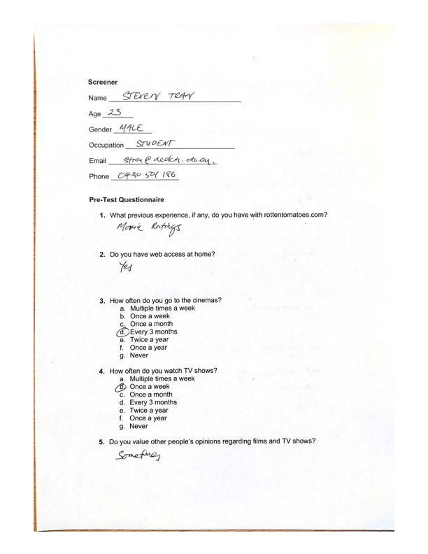

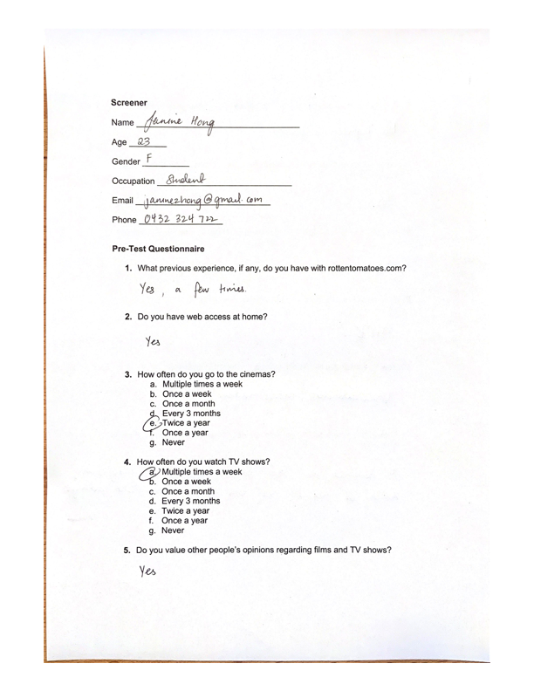

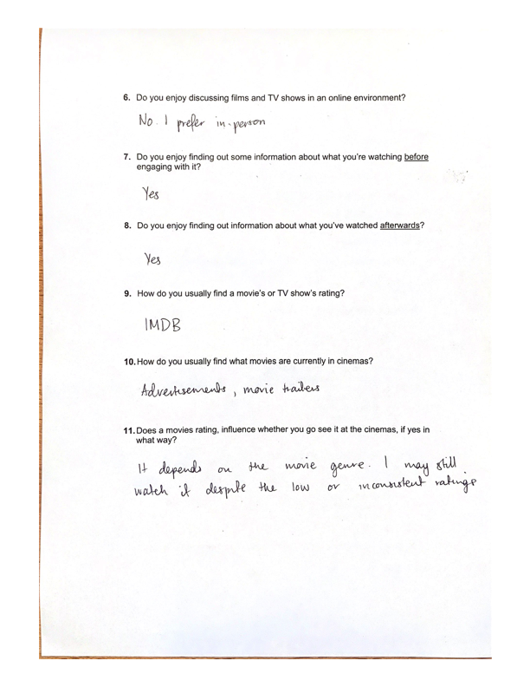

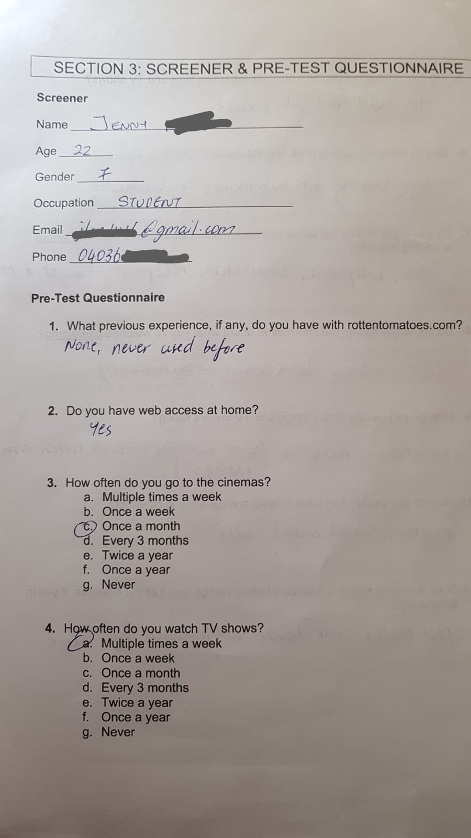

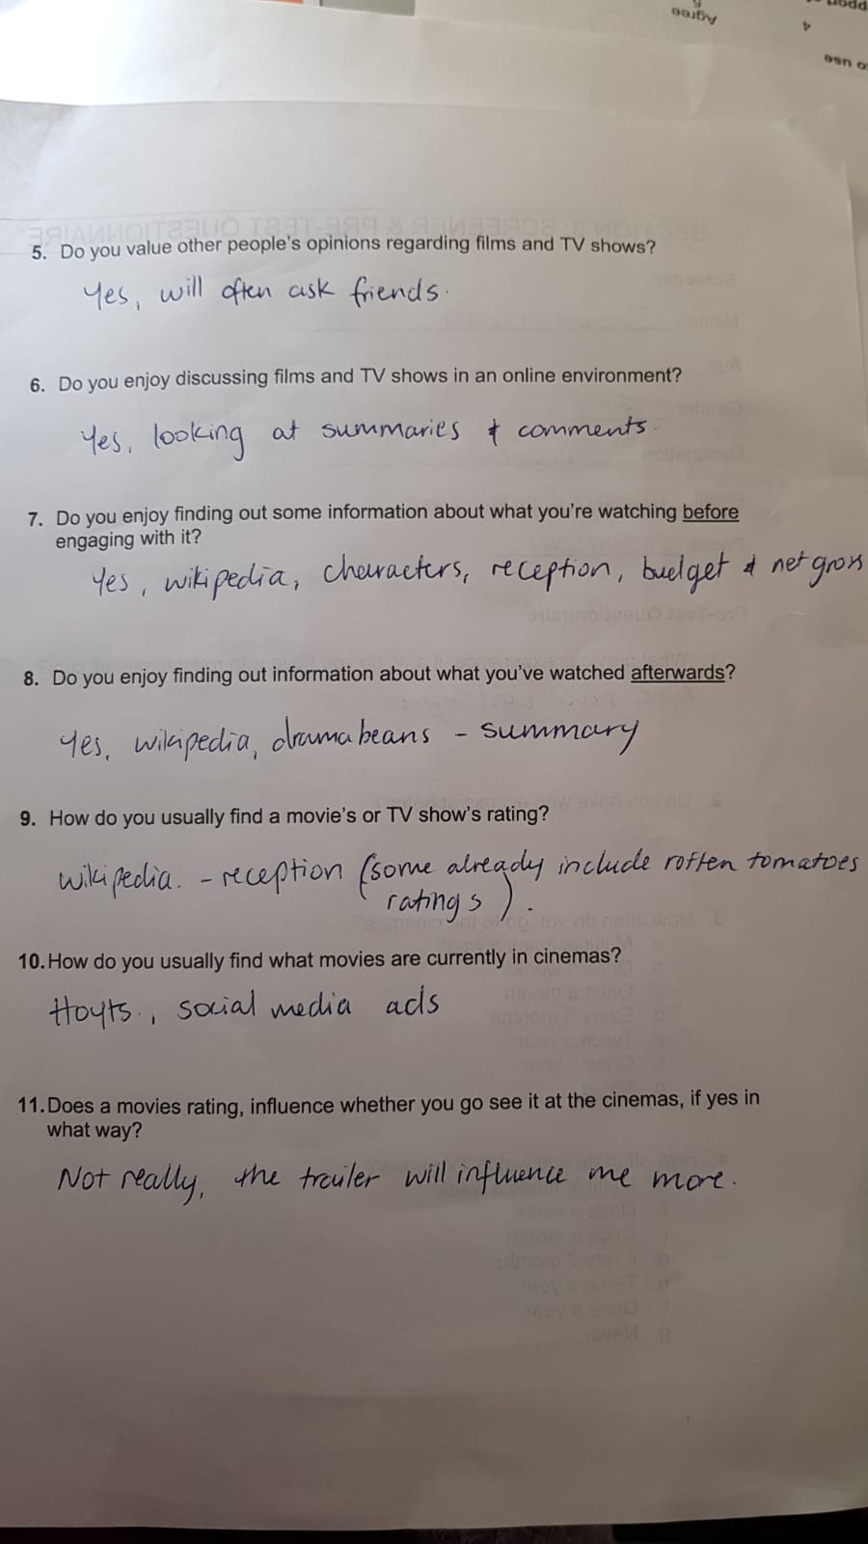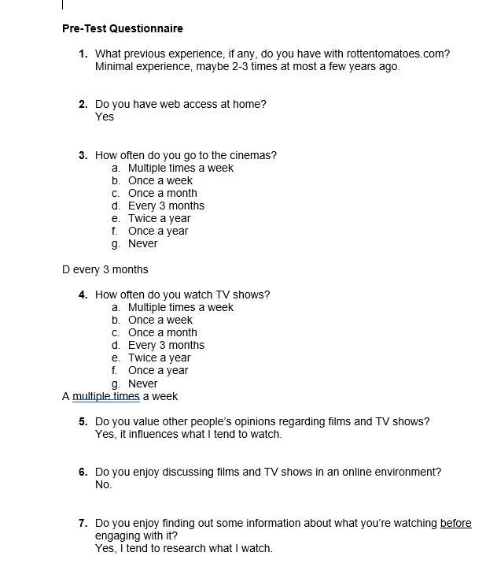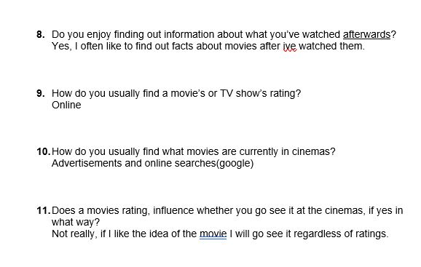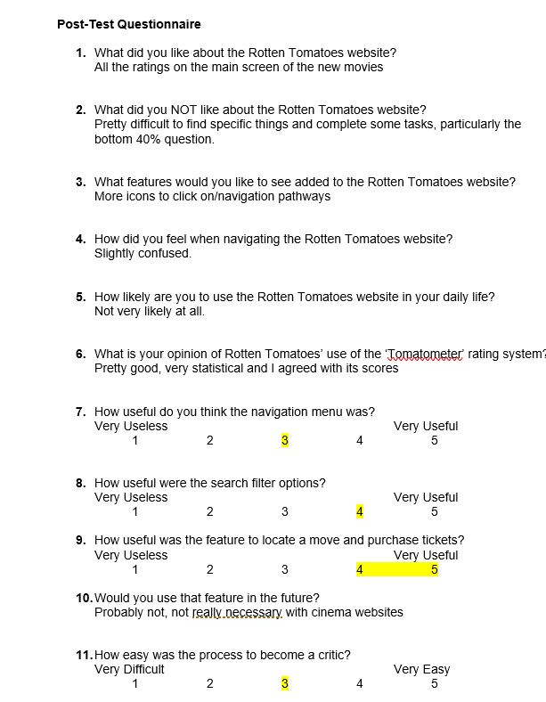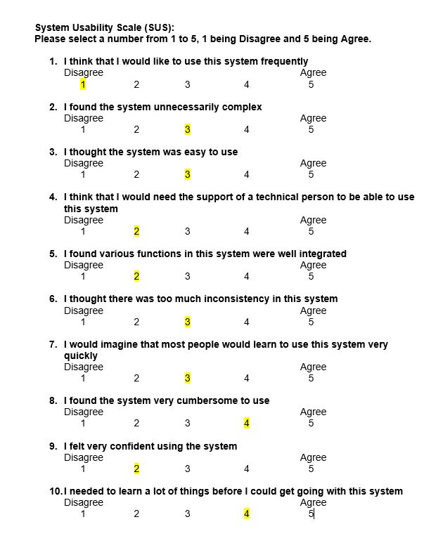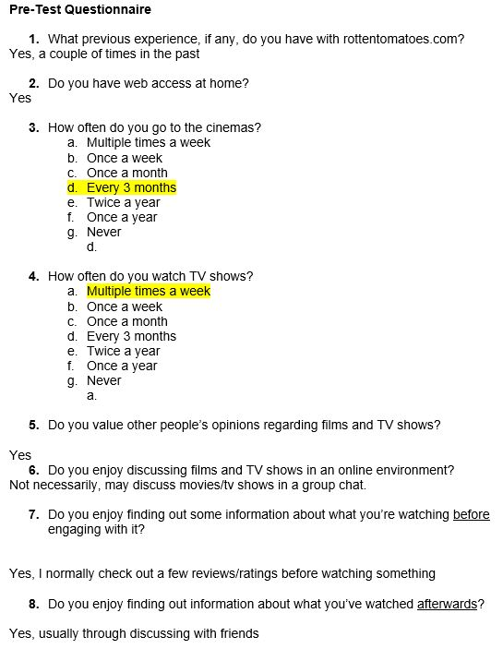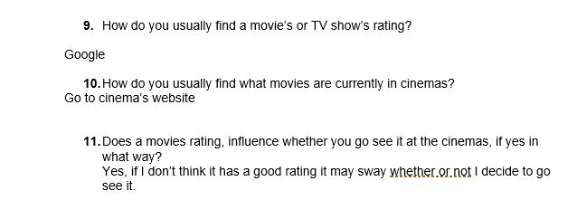

### A.2 Consent Release Form

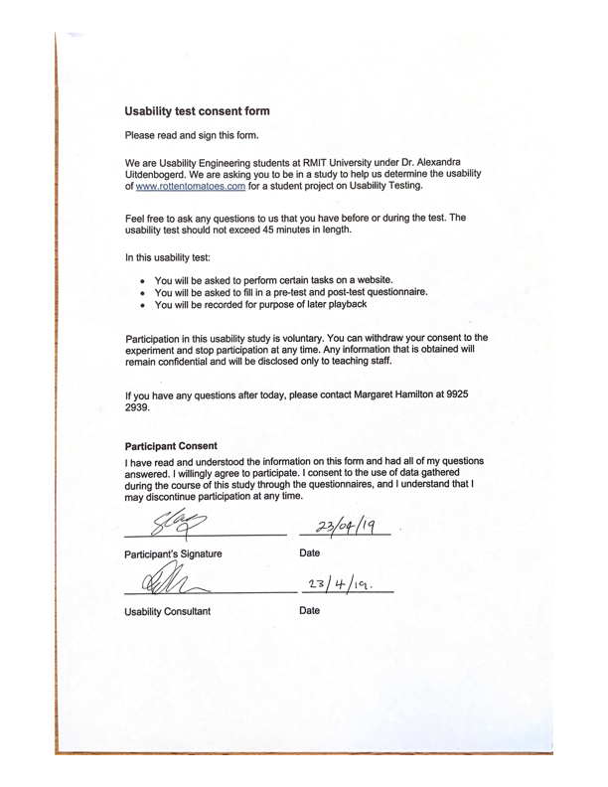

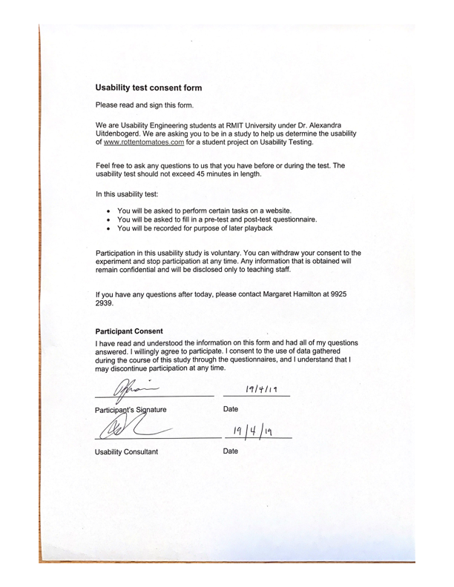

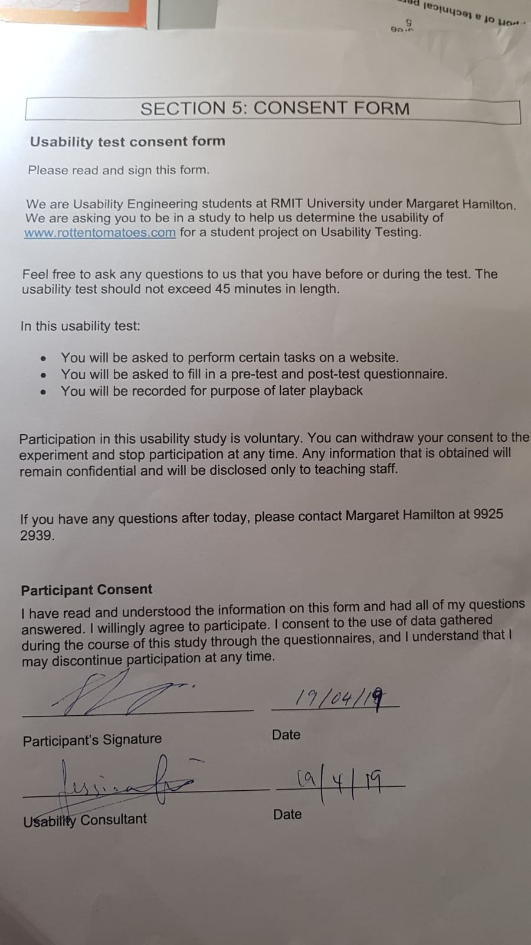

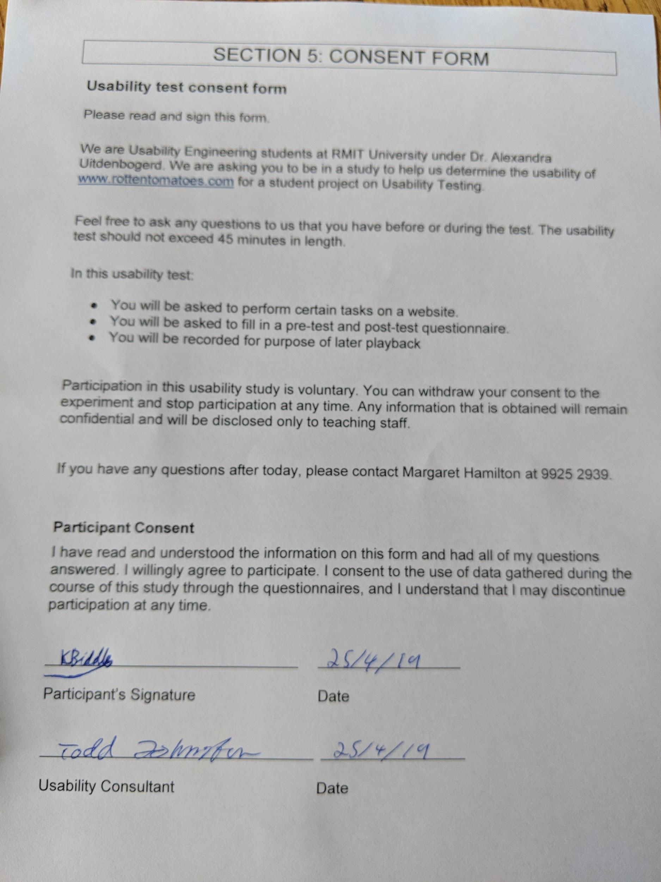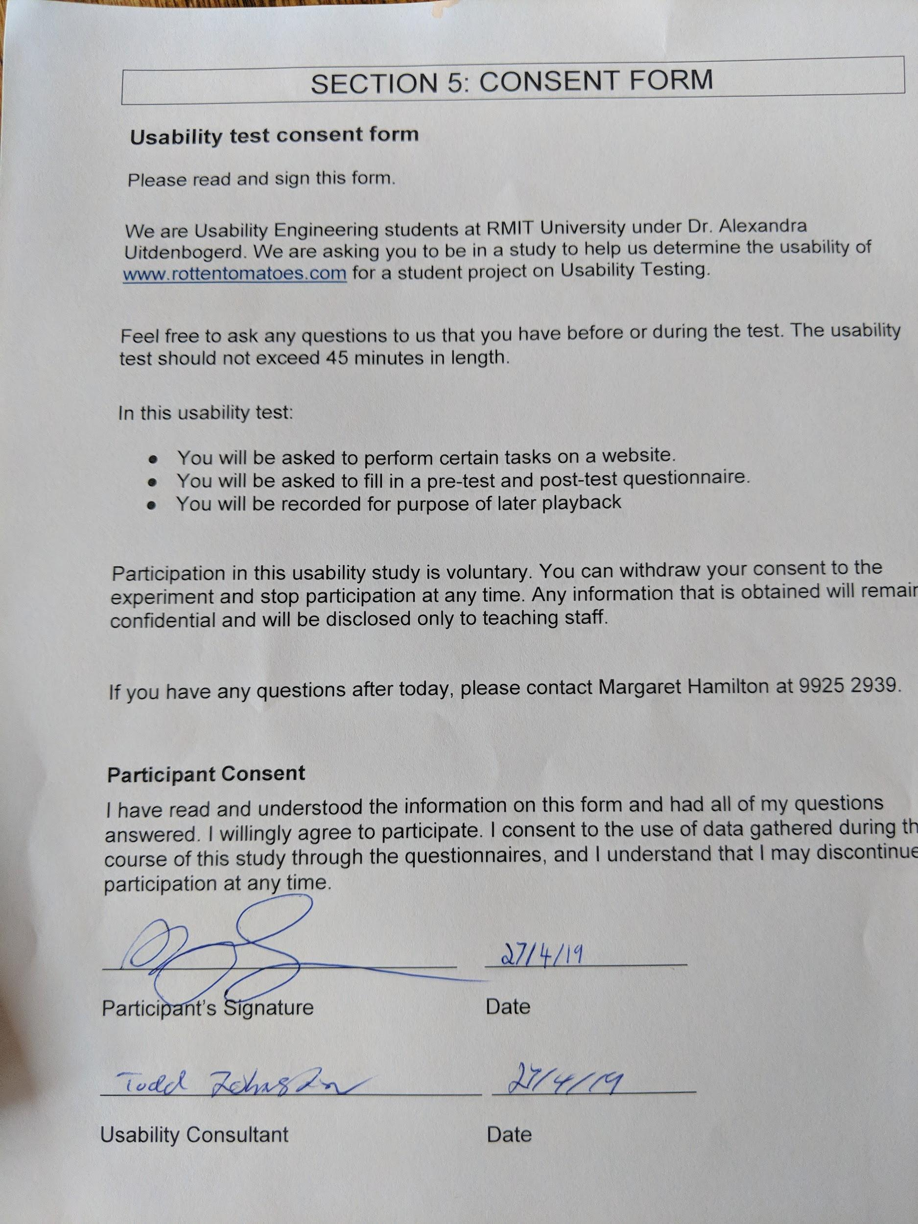

### 

### A.3 Task Scenarios

**Task 1:**

You are thinking about going to see a movie and find it has a website-specific rating, you are unsure about what this icon means and are looking to find out its meaning. Via the Rotten Tomatoes website, find out the meaning of its ratings and how they are calculated

**Task 2:**

You want to watch a new horror movie this weekend but have watched all the movies you currently own and want to go out with some friends. Using the Rotten Tomatoes Website find a list of horror movies to pick from that are currently in the cinemas for you to watch this weekend.

**Task 3:**

You want to find a ranking of the best “110 science fiction movies” that lists a synopsis, cast list as well as the website specific rating. On this ranking, you want to know what is number 1. Find this on the Rotten Tomatoes website.

**Task 4:**

You want to find out what movies are ranked in the 40th percentile and below of the websites rating system. Find a movie on Rotten Tomatoes in the bottom 40% based on ratings.

**Task 5:**

Imagine you are a film critic for an independent publication with a large following. You want to get your reviews incorporated in the critic-based scoring system and your reviews posted to the critic’s reviews section. Your task is to attempt to become a critic that satisfies the prior needs.

**Task 6:**

You are planning a holiday to Los Angeles, and realise you have a spare day at the start of the trip. Using www.rottentomatoes.com find a movie to watch at the cinema. You are staying in postcode 90210 and want to see a film at the nearest AMC brand cinema to your hotel. You want a session between 12pm and 5pm of any film, you want to sit in the front row and checkout as a guest.

# 

### A.4 Post-Test Questionnaire

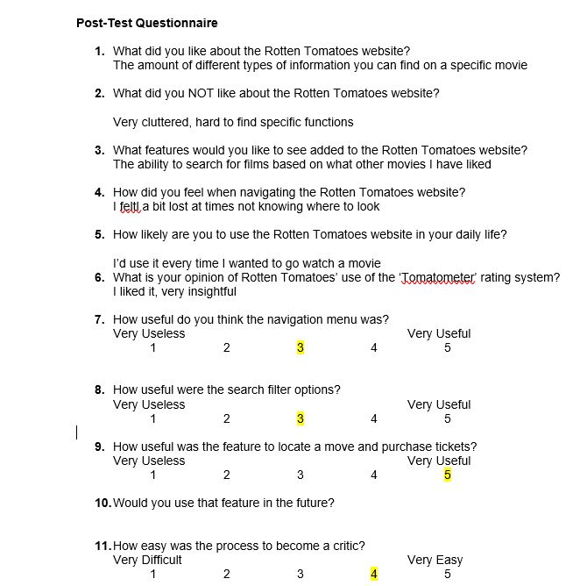

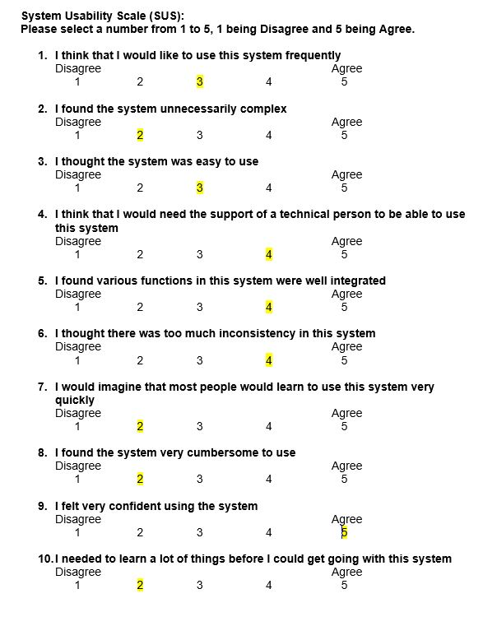

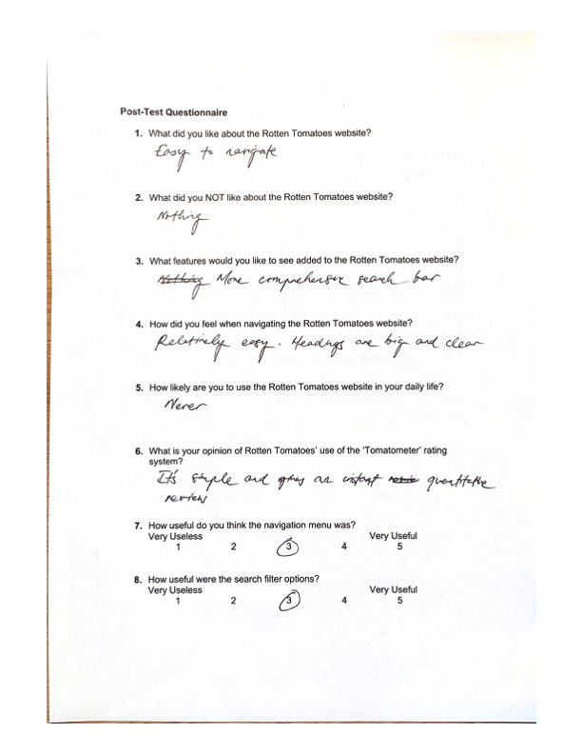

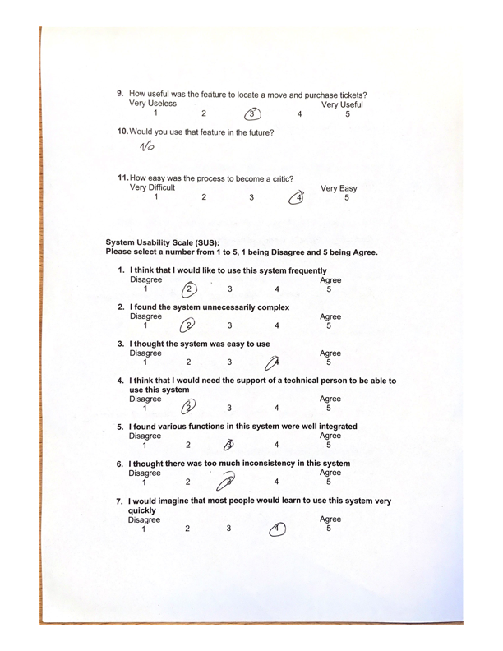

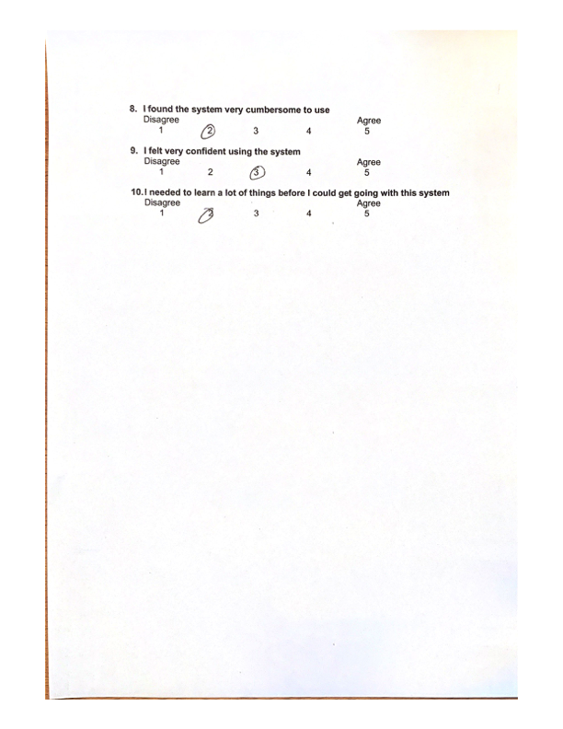

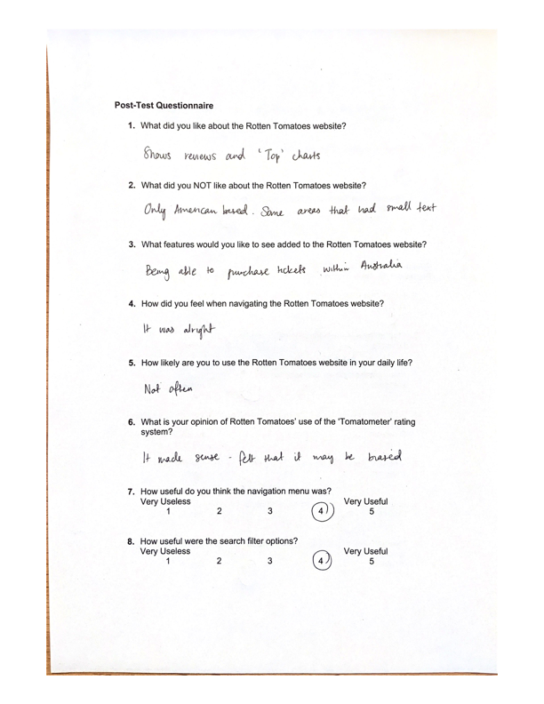

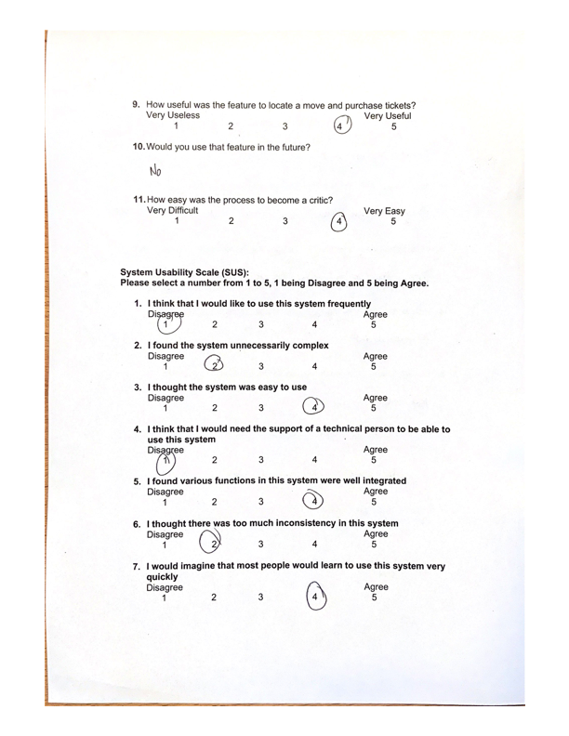

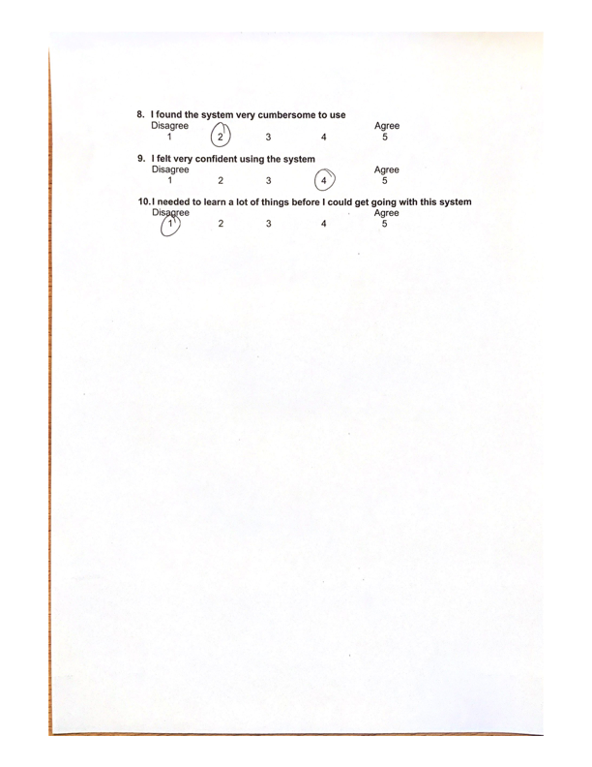

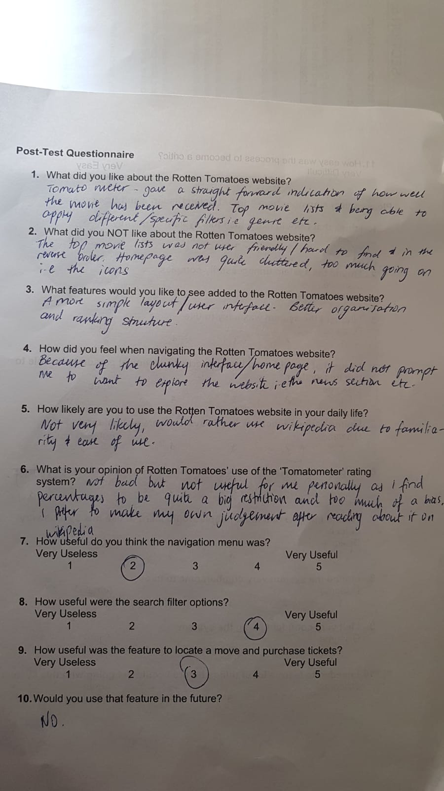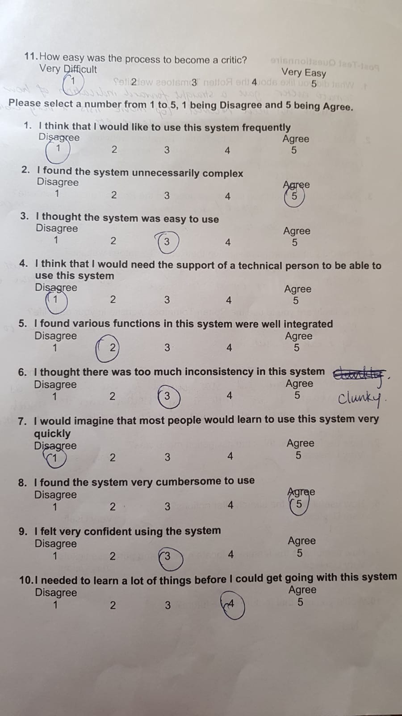

### A.5 Data Observation Notes

19:30 in total

Task 1 - 4:07.64: finding the tomatometer rating and what it means

• Scrolled down on home page, clicked on the tomato icon, which linked to another icon and clicked it again

• Believes that it now means that they've made a review

• Clicked on certified fresh

• When back two pages and clicked on the popcorn icon

• Browses the menu

• Very confused as to what the icons mean

• Scrolled down and found certified fresh

• Scrolling on the home page and clicked on grea icon

• Read the description and looked at the percentage

• She encountered the keyword 'tomatometer' but didn't know what it meant and didn't consider to explore it even further

Task 2 - 0:44.67: finding a movie based on horror genre

• Movie menu tab

• Opening this week

• "let's see how we can filter this"

• Sort by and then looked at hte list and clicked on horror only

Task 3 - 4:07.20: best 110 sci fi

• Menu top movies

• Looked at genre

• Went to sci-fi

• Went to top 100 scifi and fantasy

• But realised there were no synposis

• Surprised because it was 100 not 110

• Now she wants to try and find out where you can find synposis

• Scrolling around the page, confused

• Scrolling through the menu

• Search bar: science fiction

• Search bar: Top 110 science fiction

• Can't click the movies thing int he drop down menu in the search bar

• Went back to menu

• Went to 'news' and clicked on all time list but was really uncertain

• Found it quickly on all time list section

• Scrolls and was mad at the thought that she had to scroll from 110 all the way down to top 1

• Scrolled all the way down and missed the next page and ended up in comments

• Scrolled up and then clicked page 4

• Scrolled down and found mad max

• She would "do it backwards"

• Really annoyed at that feature

Task 4 - 1:35.75: filtering to bottom 40%

• Scrolled in the home page and just found an icon percentage that was less than 40%

• Top movies

• Opening this week

• Use the slider

• Found 2 movies

Task 5 - 5:06 - how to become a critic

• Top bar

• News

• Critics consensus - unsure if that was correct

• Realised it wasn't

• Scrolled down

• Found jobs and then found critics submission on the bottom menu

• Read through the requirements and saw "submit application here" which was a hyperlink

○ "would miss this if i were skimming"

○ "hidden"

• Read through to the bottom and saw the submit application

• Scrolled up and clicked on the "here" text link

○ (didn't click the submit application on the bottom because it was preceded by a grey text box which seemed like a terms and condition thing and the name "submit application" made it seem like she can completed the application already rather than fill one out)

○ The other option isntead said "if you want to become a critic click here"

○ More of a call to action

• So many steps, on different pages it wasn't all listed out

• Accidentally submitted whilst click on the right arrow and it never said "submit application"

• Really in disbelief when she submitted

Task 6 - 3:47

• Top menu went to tickets and showtimes

• Don't know how to change the location's postcode, not the entire location because it was already set to LA

• Selected AMC sunset 5, AMC century 15 on the left

• Confused as to how you know which is the nearest cinema

• Saw that it was within 3 miles

• Still unsure

• Didn't know how to filter time or if she should just scroll

• Clicked load more but that loaded more locations rather than filter options

• Can't filter time so just scrolled through and found a movie she wanted to watch and then see if there was an available session time

• Chose dumbo 3:40pm

• Chose seat A9 by clicking on the chair map

• Searched for the option to check out as guest

### 

### A.6 Facilitators Script

Hello! My name is [facilitator’s name]. Welcome to our facility today and thank you for taking some time out of your day to participate in this usability test, we really appreciate your effort. Your feedback and insights about the user interface of the Rotten Tomatoes website will be a very useful addition to the usability research my team is conducting.

Now, let’s get you settled in and familiarised with our testing facilities before we begin the test. Over here is our usability room, where myself and two observers will be with you whilst you’re using the website. As you may recall in our formal invitation, it mentioned that there will be a screen recorder used to record your session. This recording is just to supplement our notes for data collection about your session and record any difficult usability issues RT exhibits, the video will be kept purely confidential and your identity will not be associated with it. If this is something, you’re still comfortable with, could you please sign this consent form to be recorded, if not we will switch it off, thank you.

Today’s session will take approximately 45 minutes and it consists of 6 tasks for you to complete. Do not worry if you cannot complete every task we’ve set, as we are testing how user friendly the Rotten Tomatoes website is, not your own ability to interact with the website. If you cannot finish a task, I will be the one prompting you to move on to the next task.

I do encourage you to think aloud with every step that you take so we can fully understand what drives your actions which will really assist in our research. For example, why are you clicking on a particular link, what part of the website layout you’re looking at, what text you’re reading. Just say everything out loud for us, there are no wrong thoughts, we just want to know what drives your navigation through the website.

Please let us know your honest opinions, ask any questions that you may have and if you genuinely feel uncomfortable with a task or the entire test, let me know because you can skip a task or absolutely stop at any time you wish. The data we’ve collected from you up until that point will not be kept without your permission.

Now here is your task sheet for today. You can get started now whenever you’re ready.

### A.7 Raw Spreadsheet of data

<https://docs.google.com/spreadsheets/d/1pkuI4ZU5RRyrNRiT4OkWlGtDnTgXsOs13tr5oaBl0AY/edit?usp=sharing>

## 

## Appendix B – Screen Shots

### Figure B.1

IA of Movies & DVDs tab does not allow the option to view all movies in general.

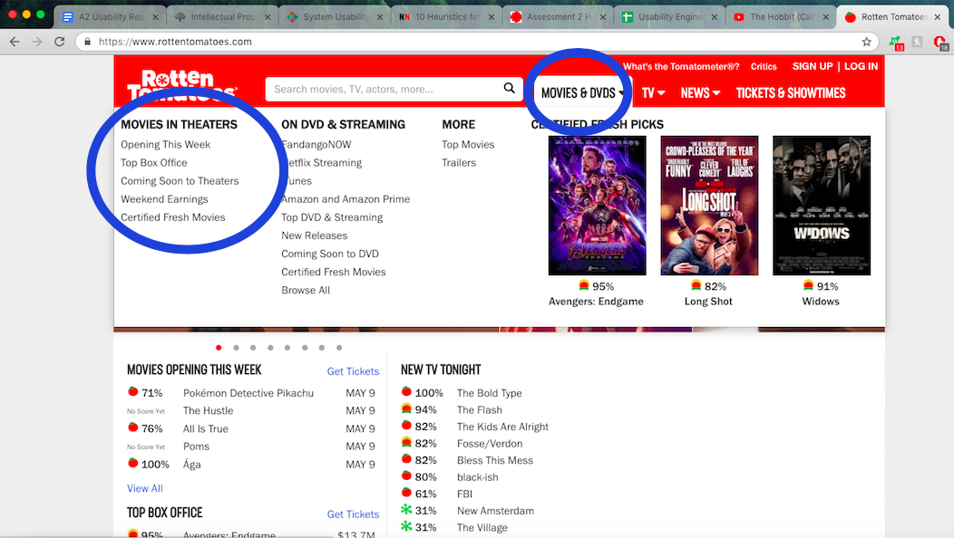

### Figure B.2

Solution to task 1 visible straight from home page.



### Figure B.3

Pathing Navigation System to help users backtrack.

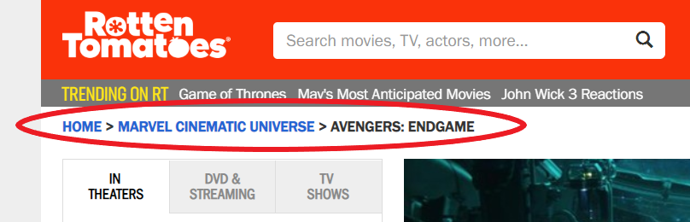

### Figure B.4

Irrelevant side menu in news drop down menu increasing clutter.

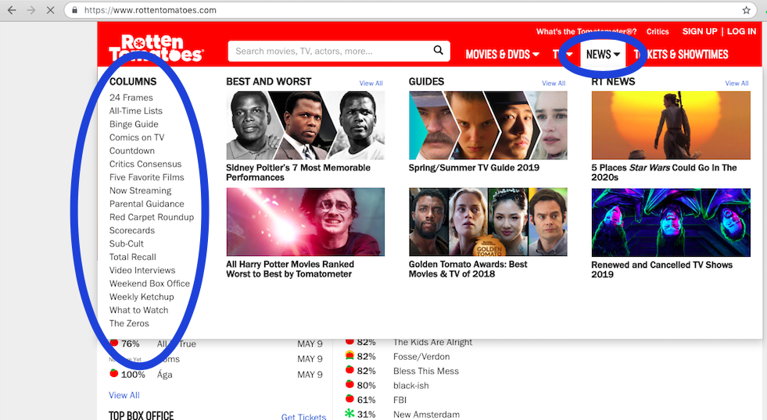

### 

### Figure B.5

Location of RT Help page, from the home page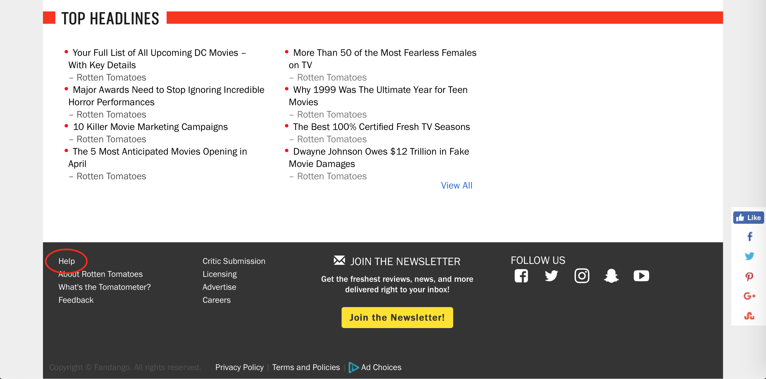

### Figure B.6

Location of the genre filter

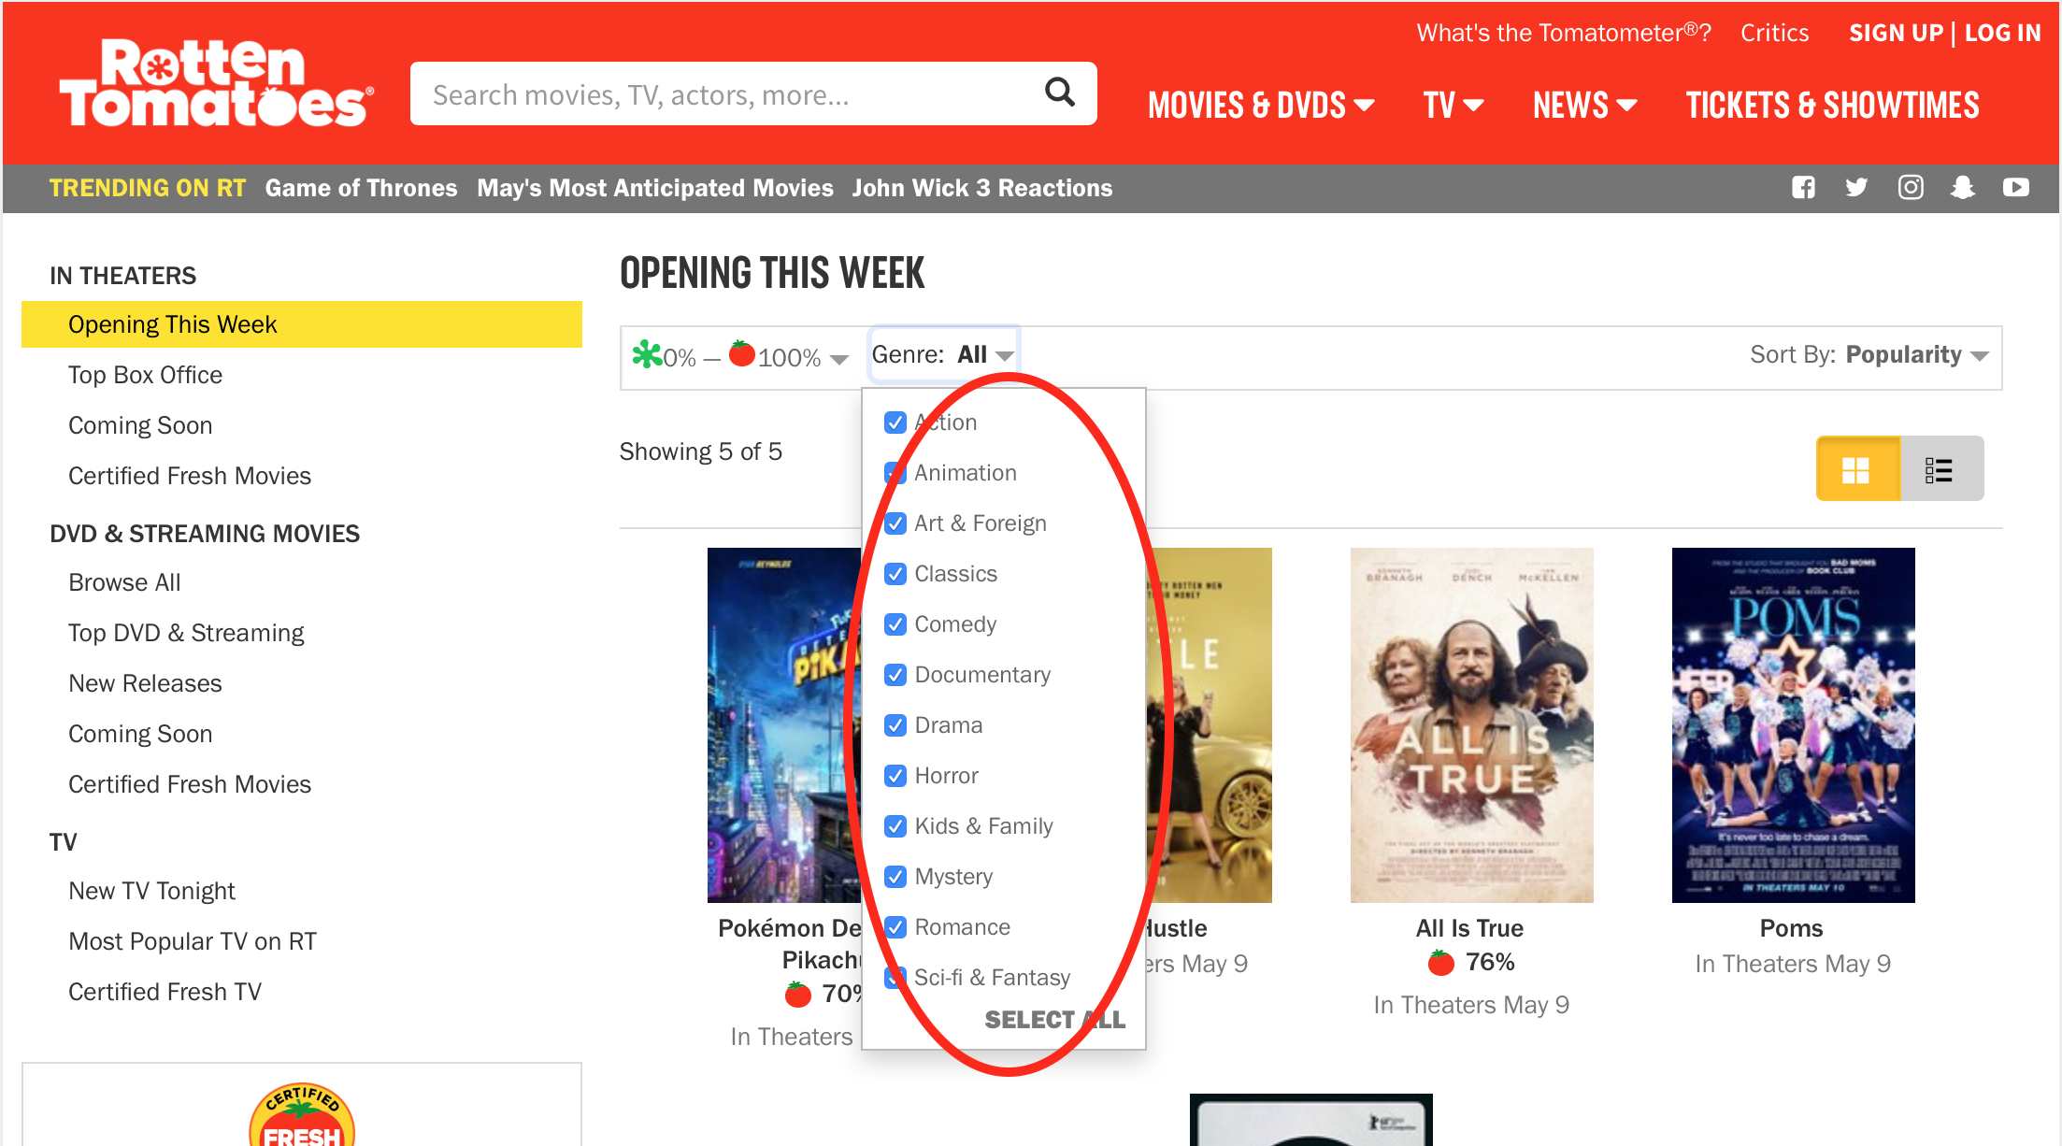

## Appendix C – Affinity Diagram

This outlines the process we have taken to analyse themes and issues with the usability of *RT*

